**Task 1**

1. Check Git Version
   1. git –version
2. Now add files with this command
   1. touch about.html
   2. touch index.html
   3. touch resources.txt

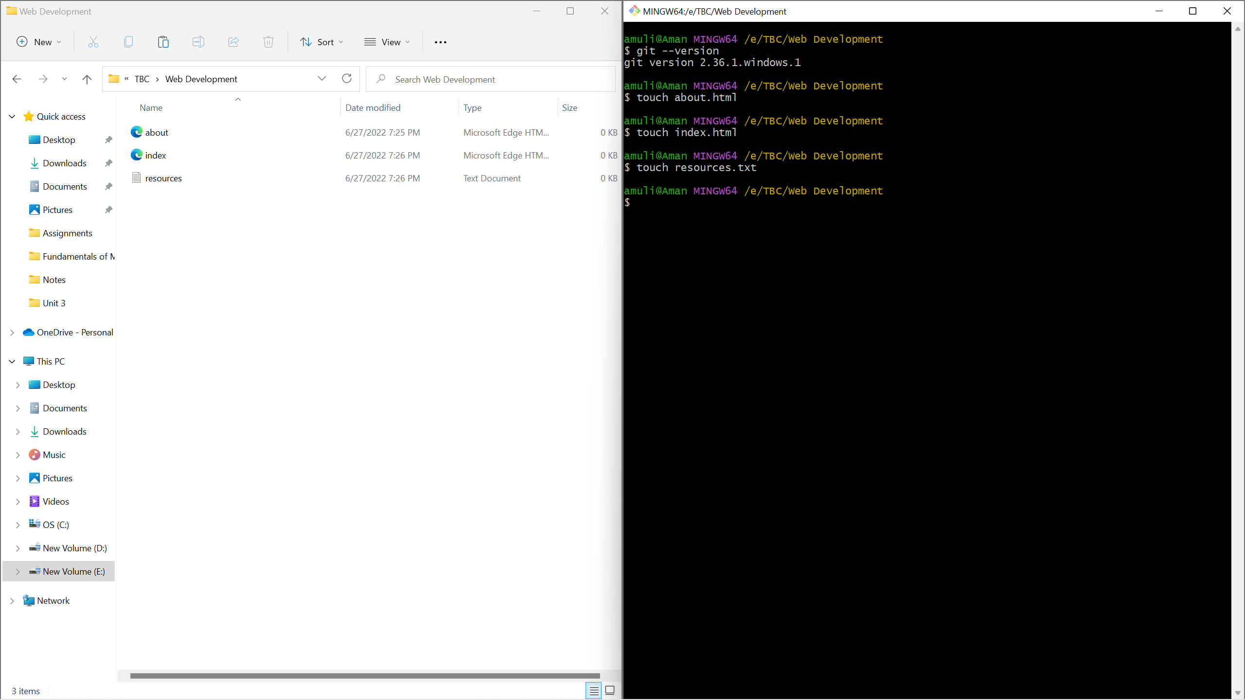

1. Open index.html in notepad and add these lines of code.

<html>

<head>

<title>My Title</title>

</head>

<body>

My First Page

</body>

</html>

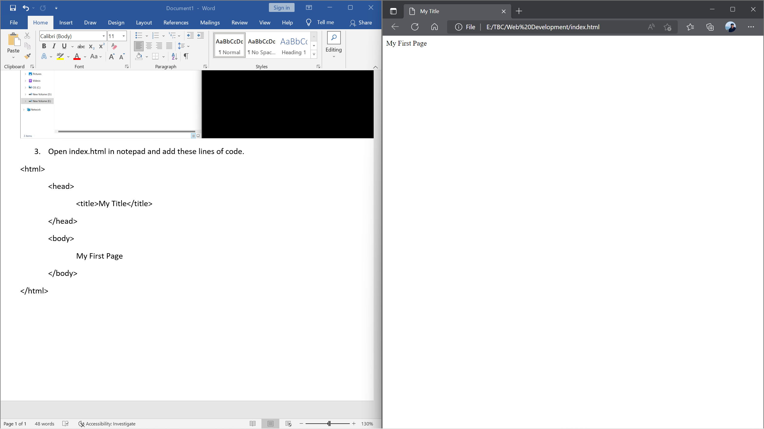

1. Open resources.txt and write your name and Save this file

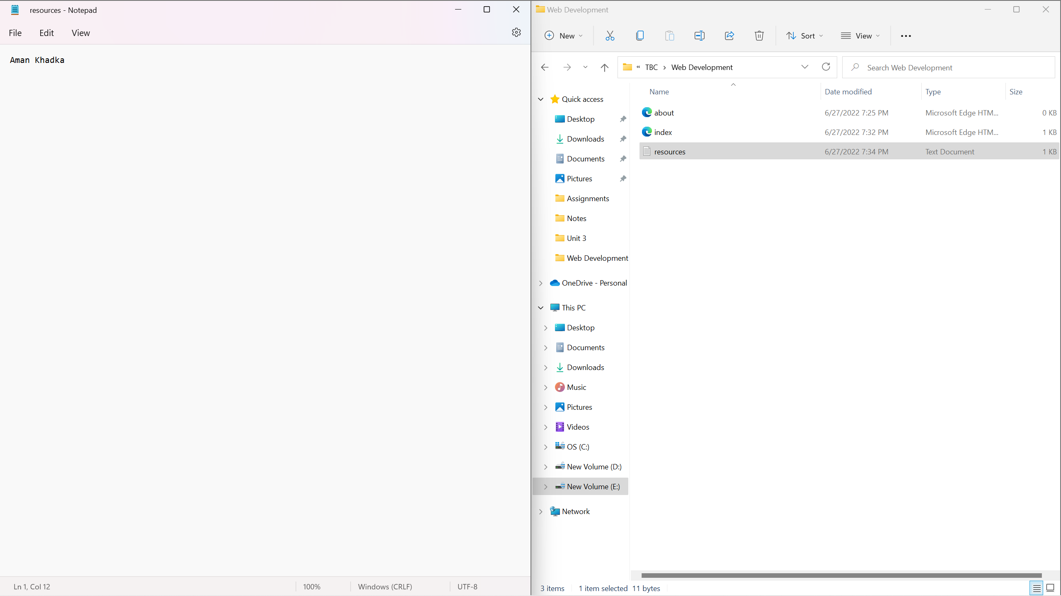

1. Initialize a Git repository/working directory
   1. git init

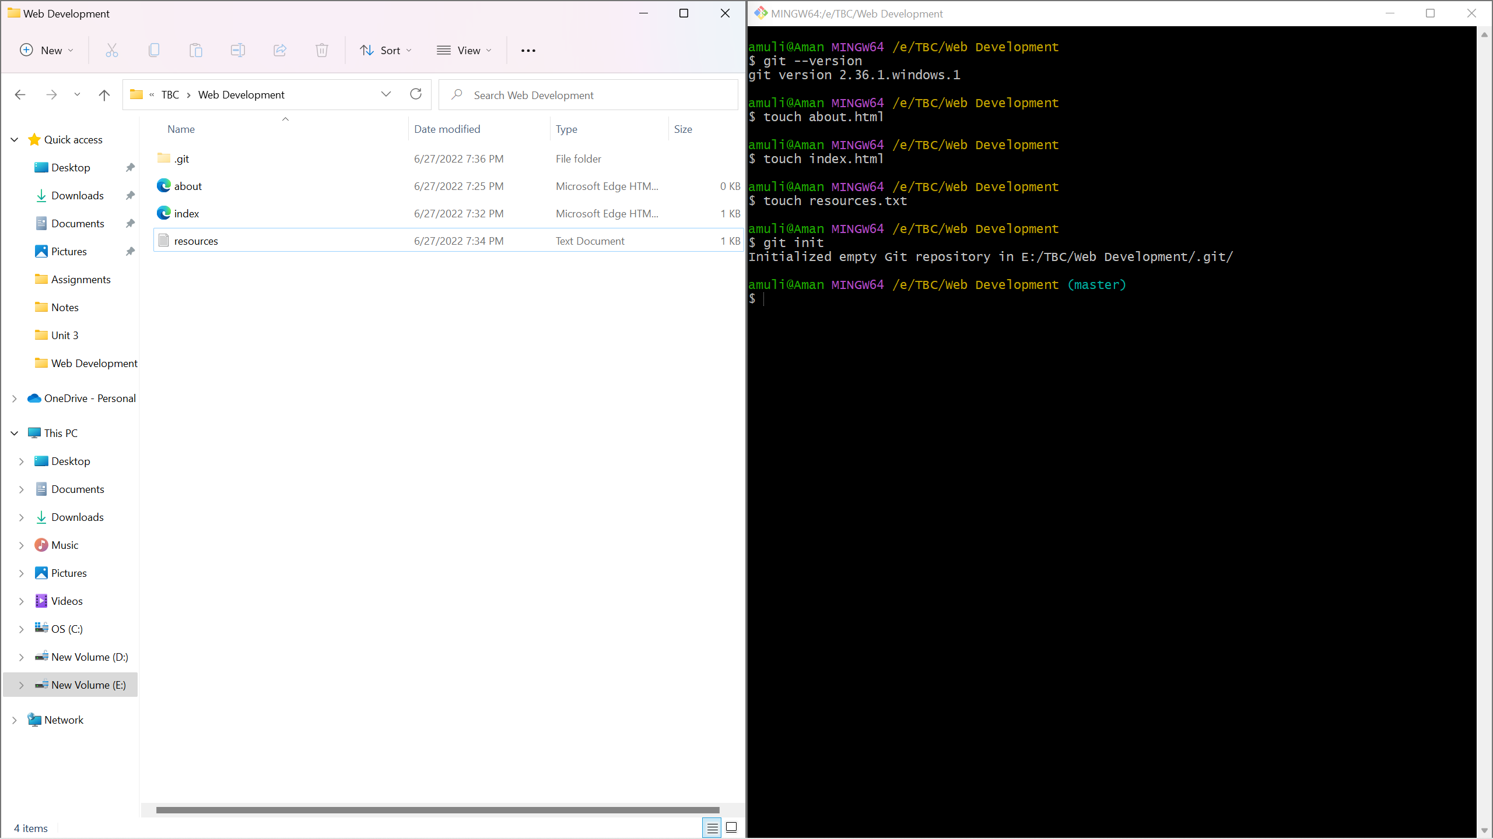

1. Configure user name and email
   1. git config –global user.name ‘Your Name’
   2. git config –global user.email ‘youremail@gmail.com’

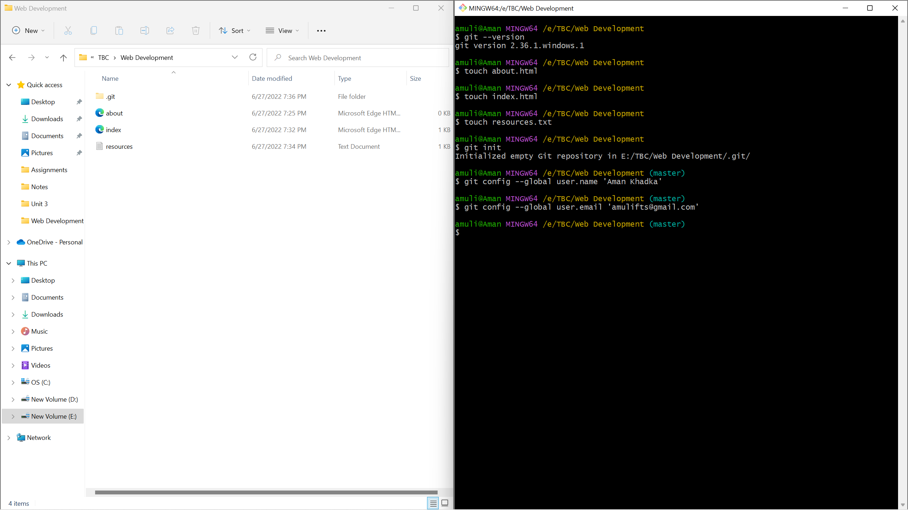

1. Check Status of Working directory
   1. git status

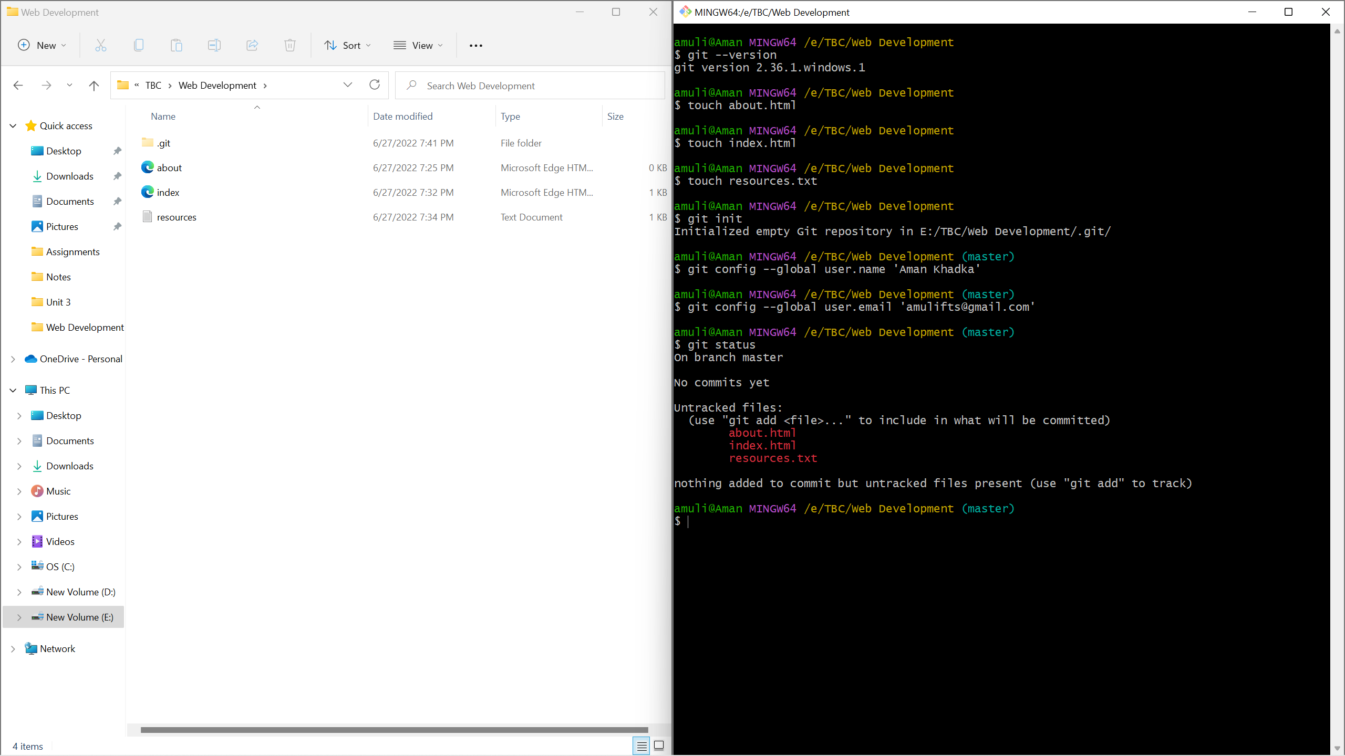

1. Add file or files
   1. git add index.html
   2. git add .

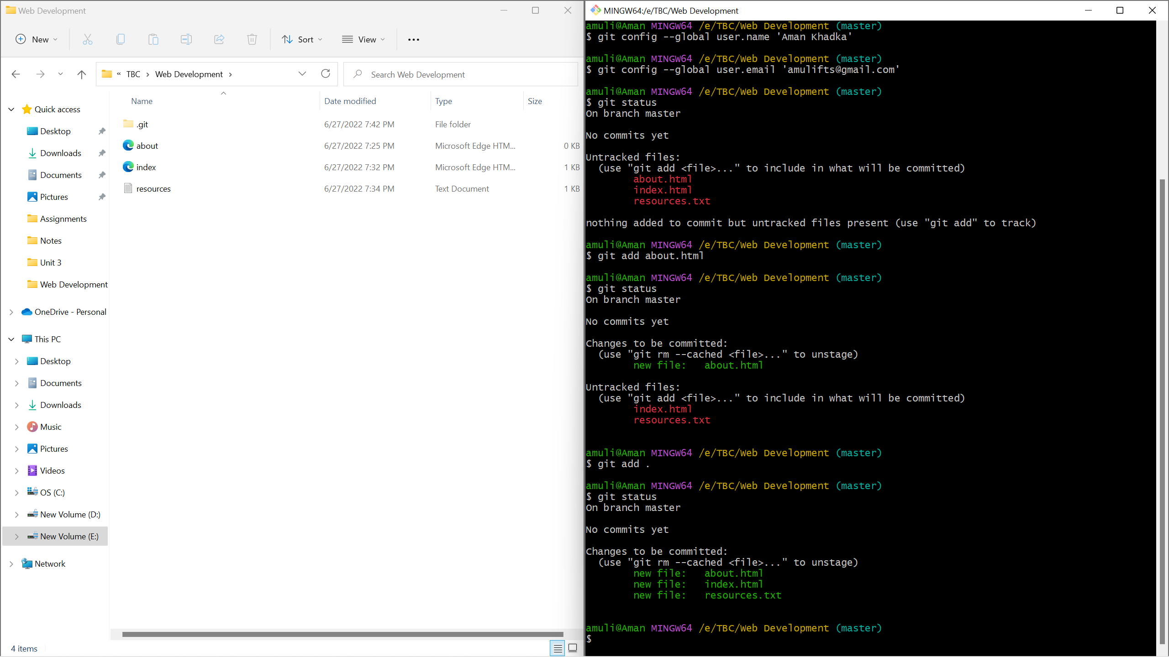

1. Commit changes in your working directory with commit message
   1. git commit -m “Commit Message”

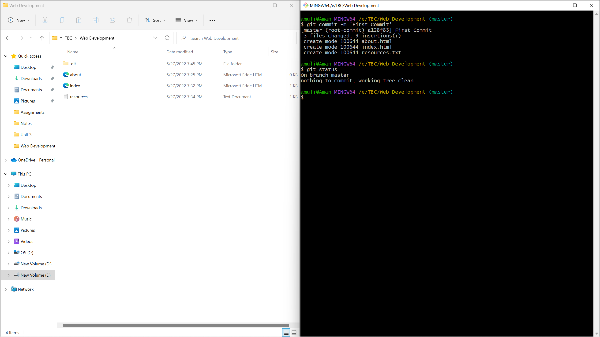

1. Add some name to resources.txt and see the changes

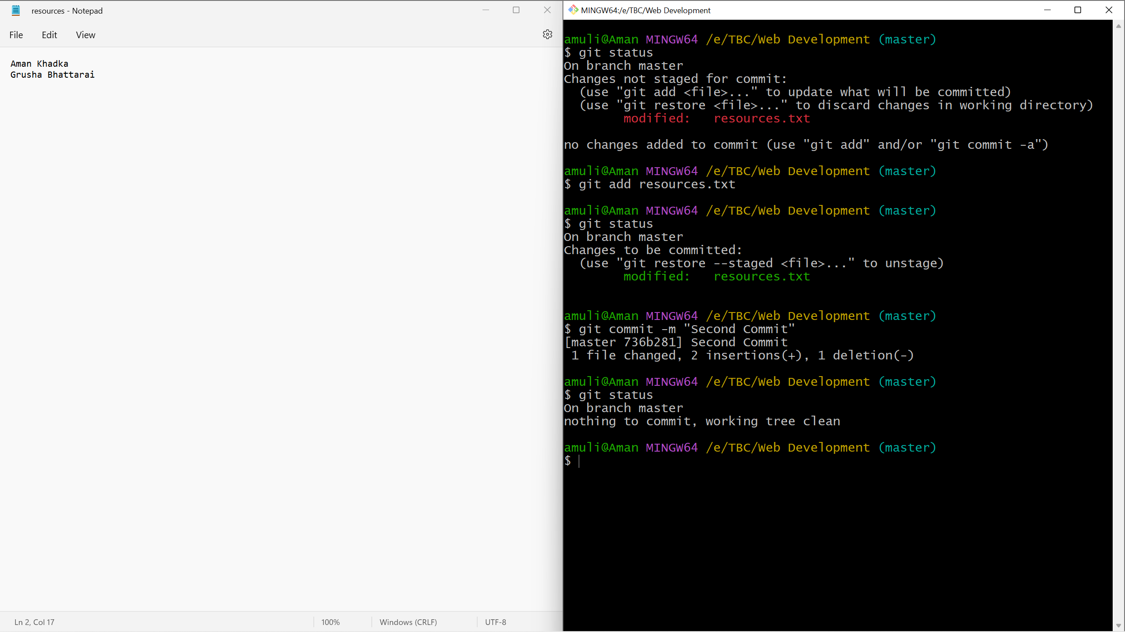

1. View History
   1. git log

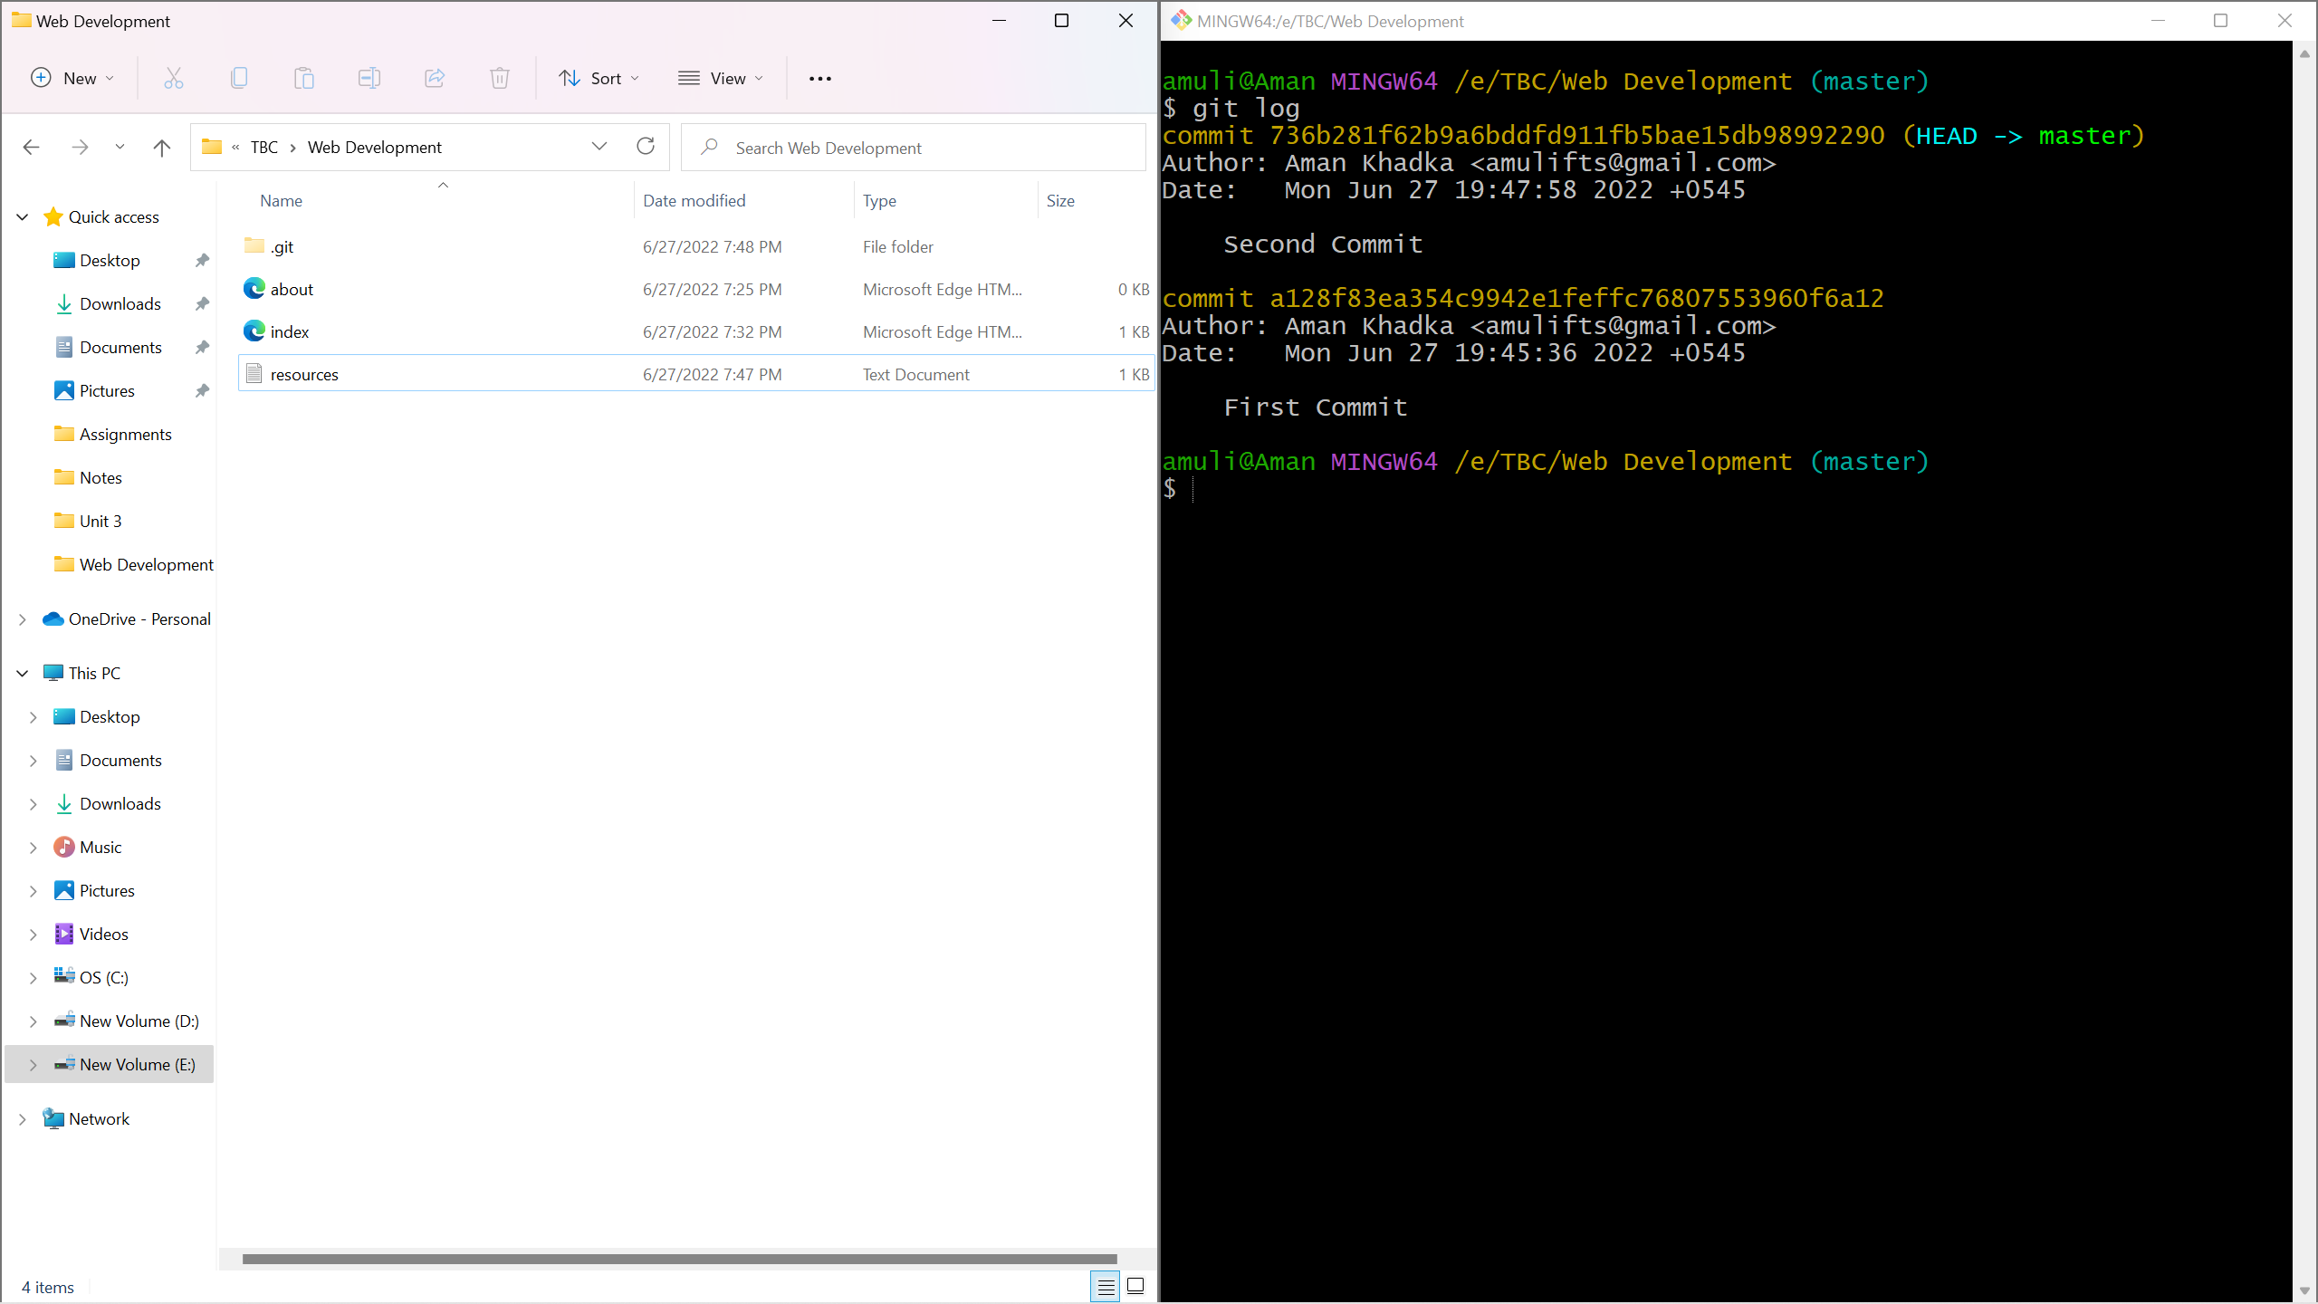

**Task 2**

1. Use Git Bash and Follow these commands:
   1. git remote
   2. git remote add origin <url>
   3. git remote
   4. git remote -v
   5. git push origin master/main

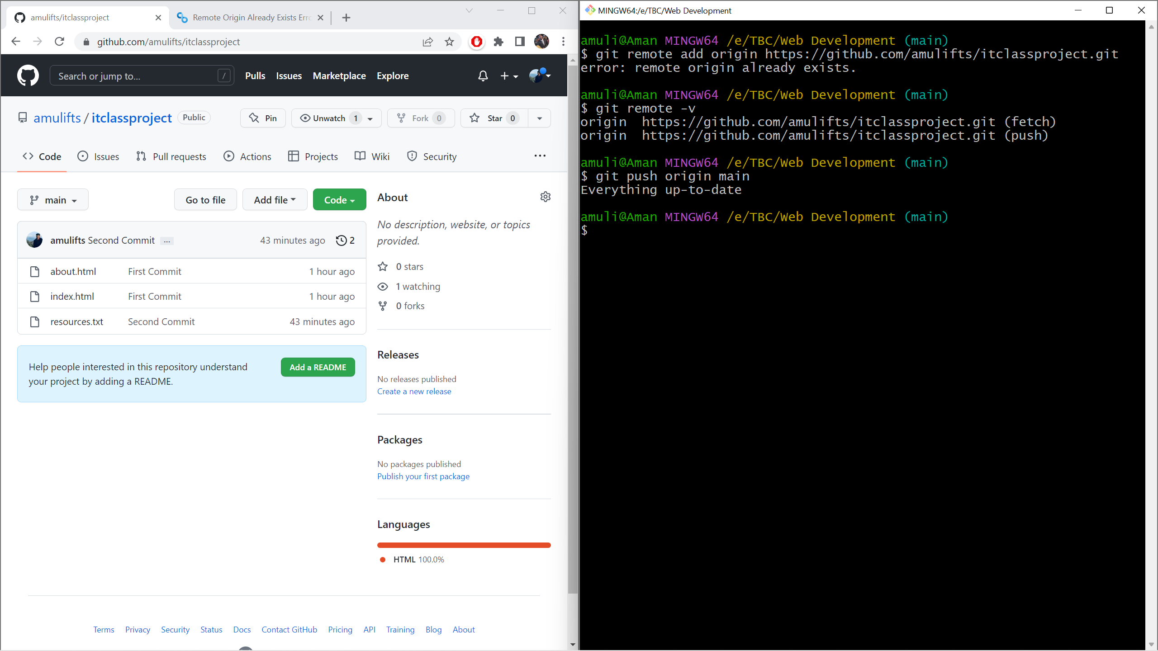

1. Clone Repository
   1. Git clone <url>

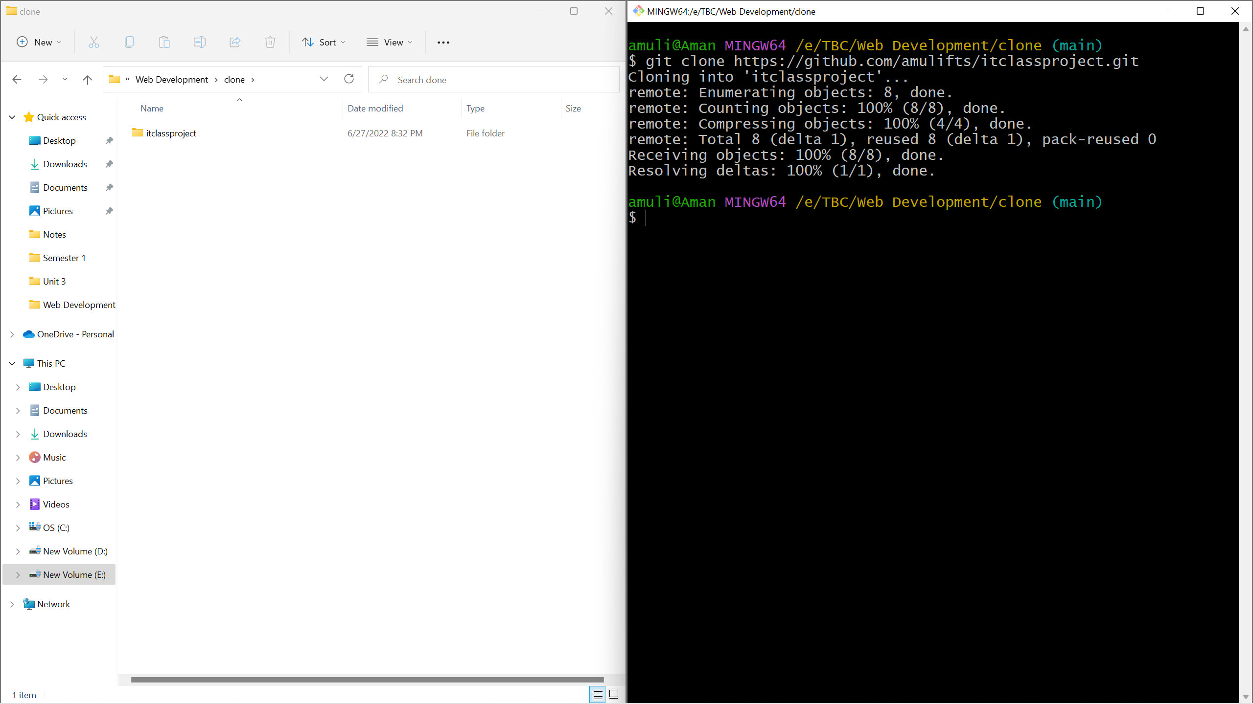

**Task 3**

1. Check the branches first
   1. git branch
2. Create a new branch
   1. git branch (branchname)
3. Check out new branch
   1. git checkout (branchname)

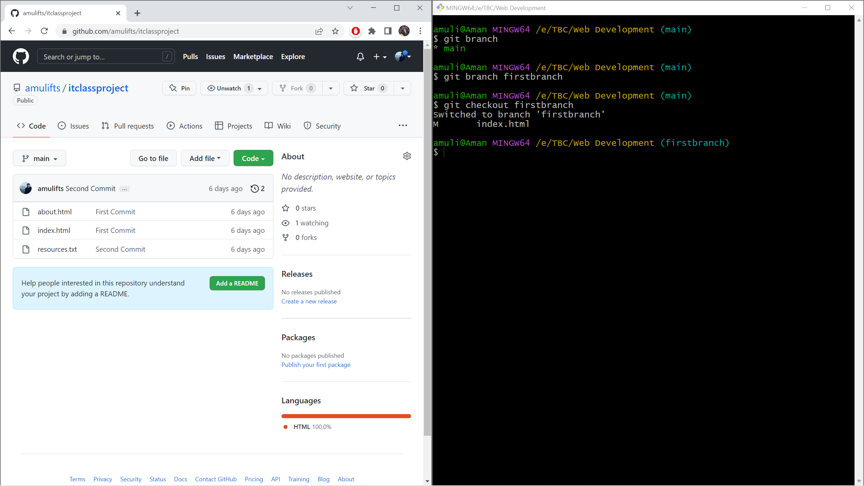

1. Now add files with this Command on New Branch & add some lines of code & save.
   1. touch newfile.html
2. Add
   1. git add .
3. Commit
   1. git commit -m “ Commit For Branch ”
4. Push to github
   1. git push origin (branchname)

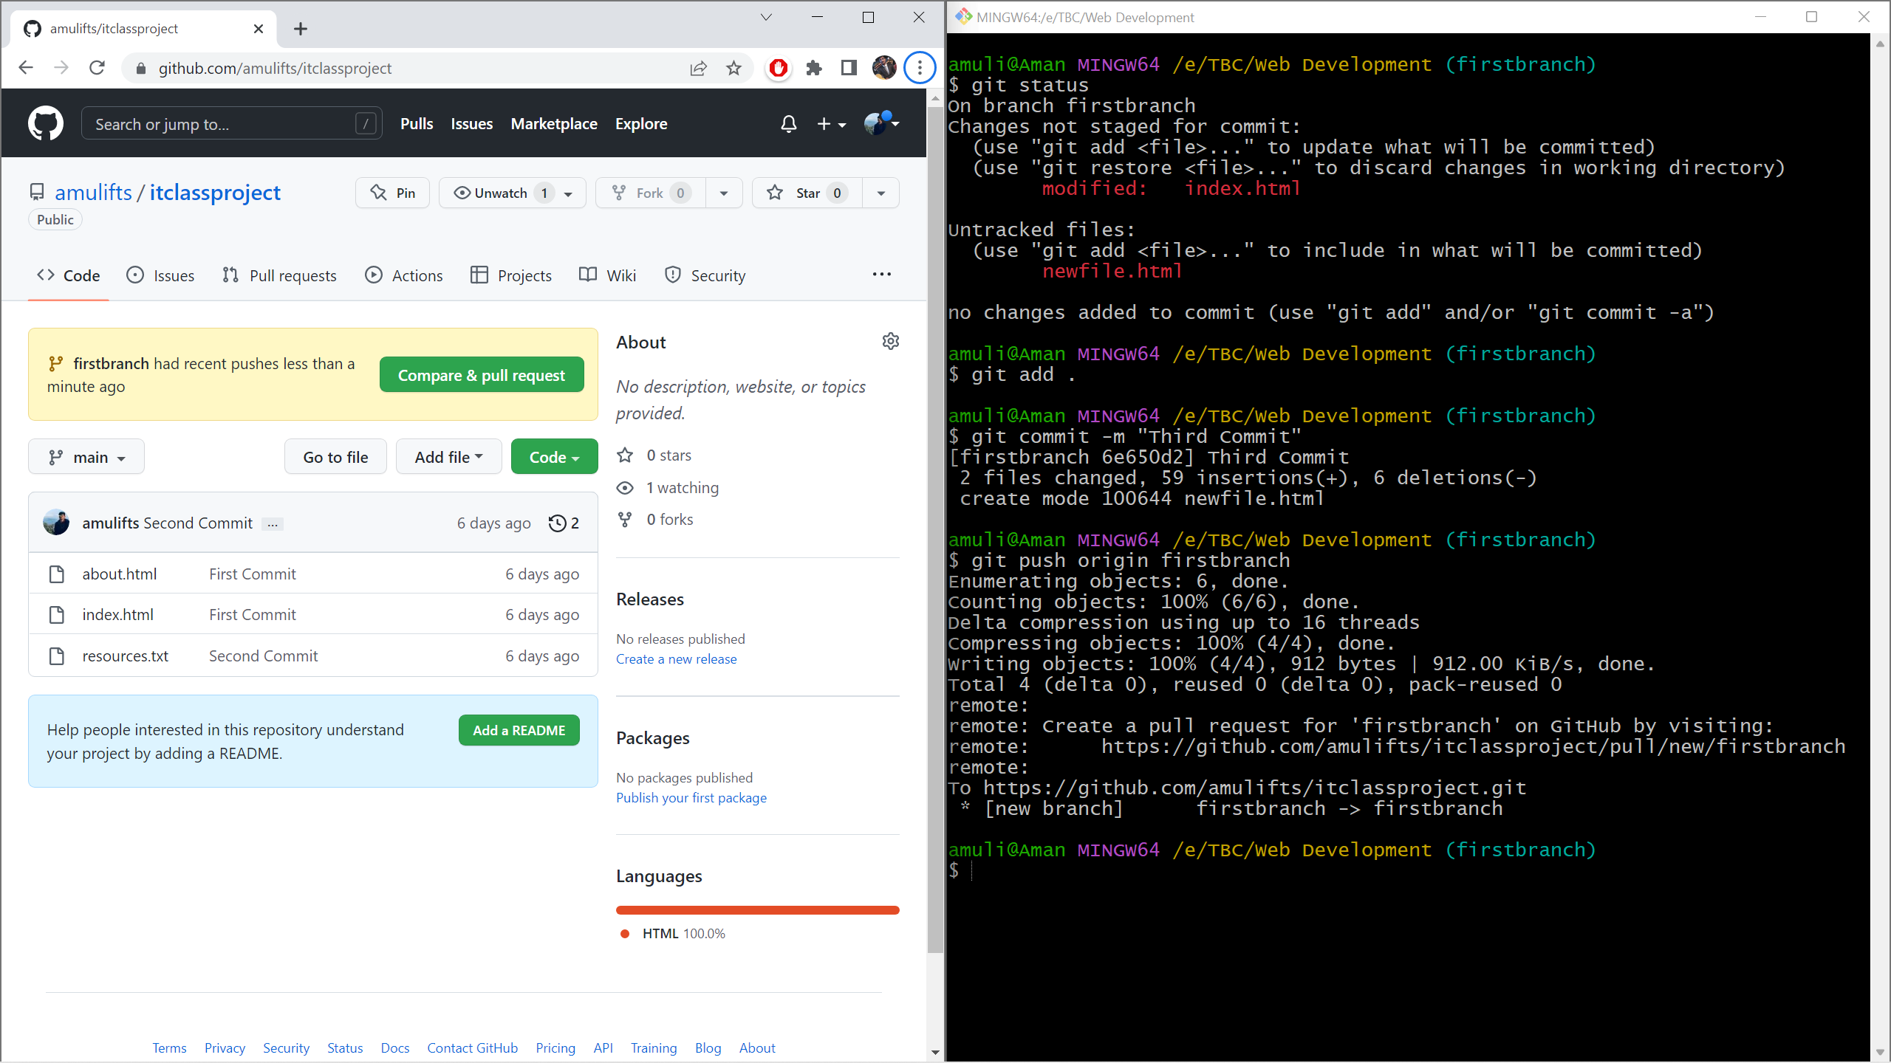

1. Check main and brach

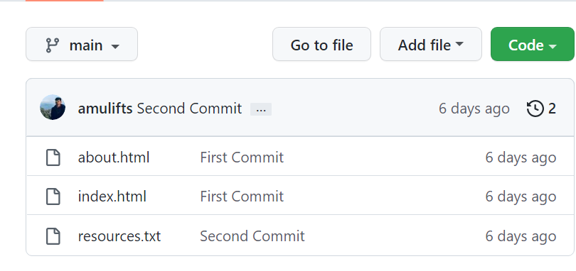

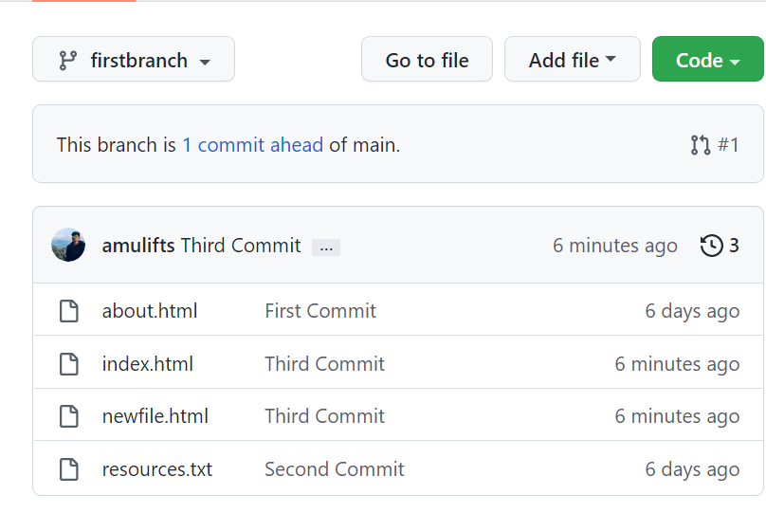

1. Merge branch with main and Push to github

